The linux command line is a powerful tool. To launch the command line, open a terminal window from your launcher.   
  
Try running the following commands, and explain what they do:

ls – prints a list of file directories to the terminal

ls –l – prints a list of unhidden files and directories

mkdir test -

cd test

touch example.txt

ls -l >> example.txt

cat example.txt

On your linux environment, use apt-get from the command line to install the following software and post a screenshot of them running:

Command: apt-get install <software>

Plank

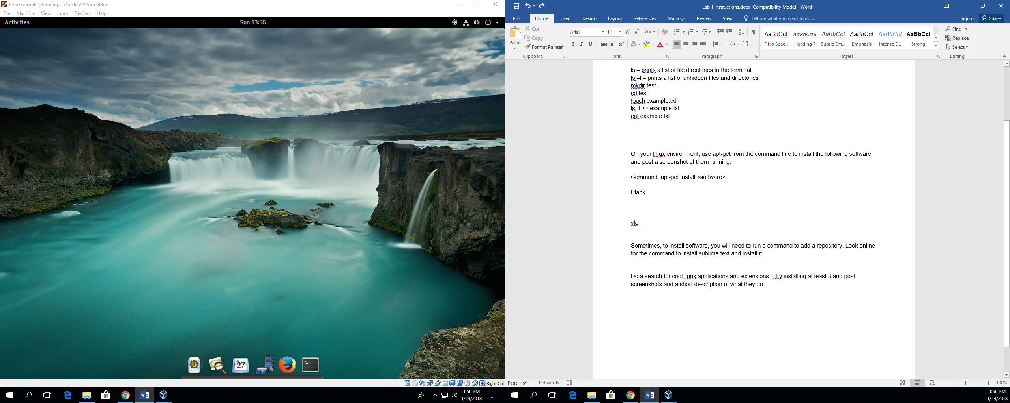

vlc

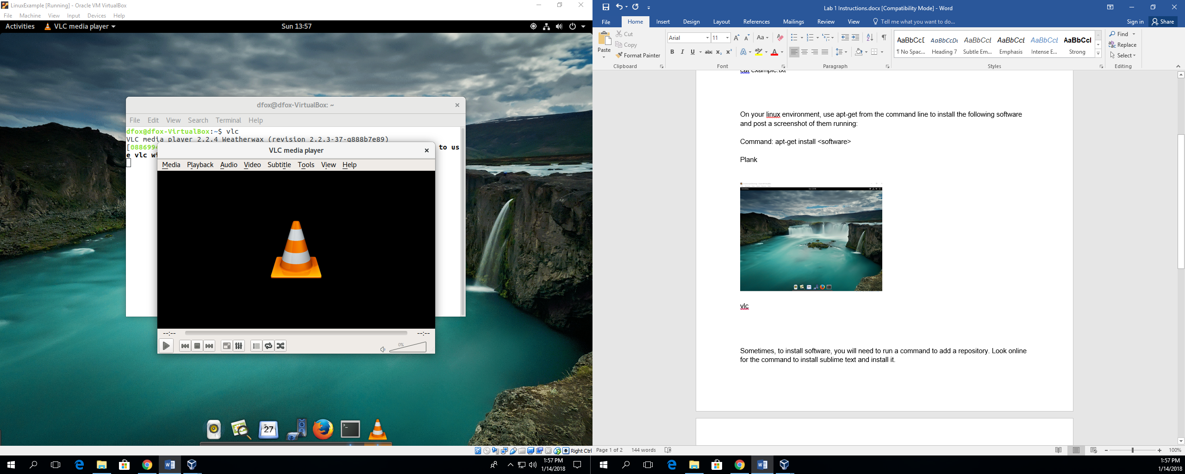

Sometimes, to install software, you will need to run a command to add a repository. Look online for the command to install sublime text and install it.

Do a search for cool linux applications and extensions - try installing at least 3 and post screenshots and a short description of what they do.